Setting up a Junit and testing using a simple test class
Step1:- Install the IntelliJ IDEA Community and complete the setup
Step2:- This screen appears when you open IntelliJ.
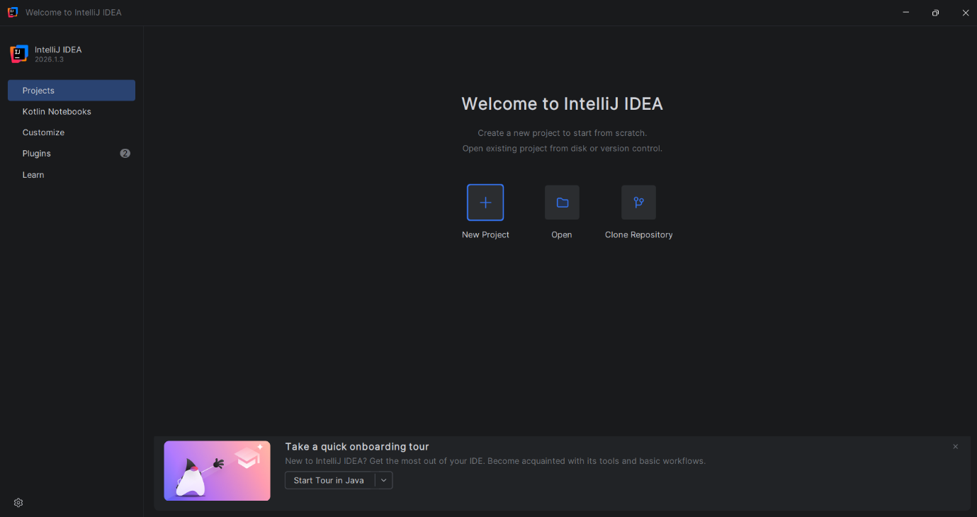
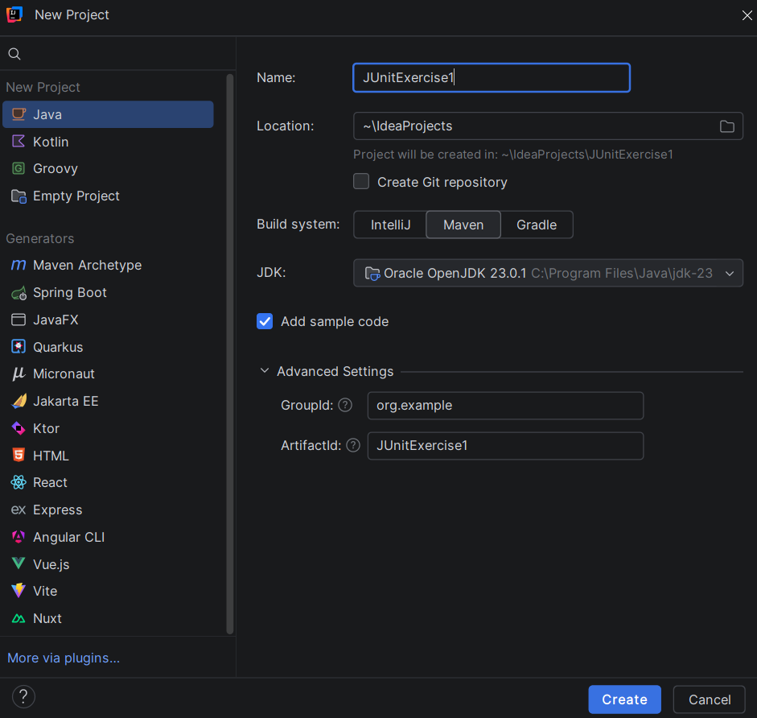
Step3:-Select project as java, Give name, and change build system to maven and click create.
Step4:- This screen appears defaultly.

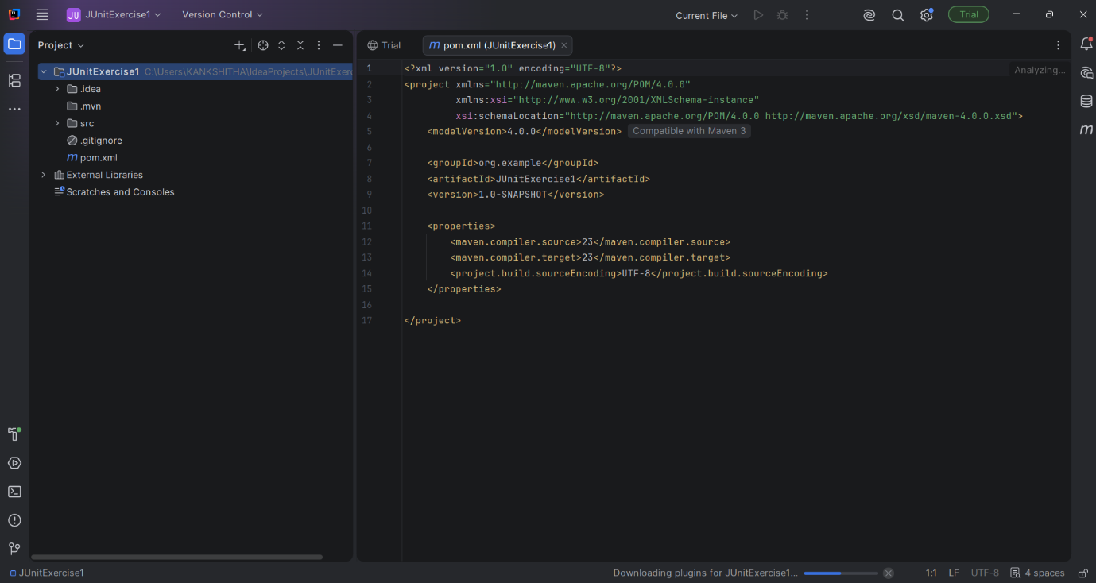

Step5:- Change the text in pom.xml as given in the exercise question.

Step6:- Once you run the code in pom.xml A version is downloaded in the external libraries automatically.

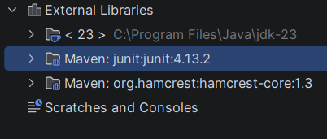

Step7:- Now follow these steps to create a package and test class
Click on srctestjavaRightclick(newpackagegive name as org.example) and press enter to create a package
After the package creation, Right click on org.examplenewjava filegive name as CalculatorTest.
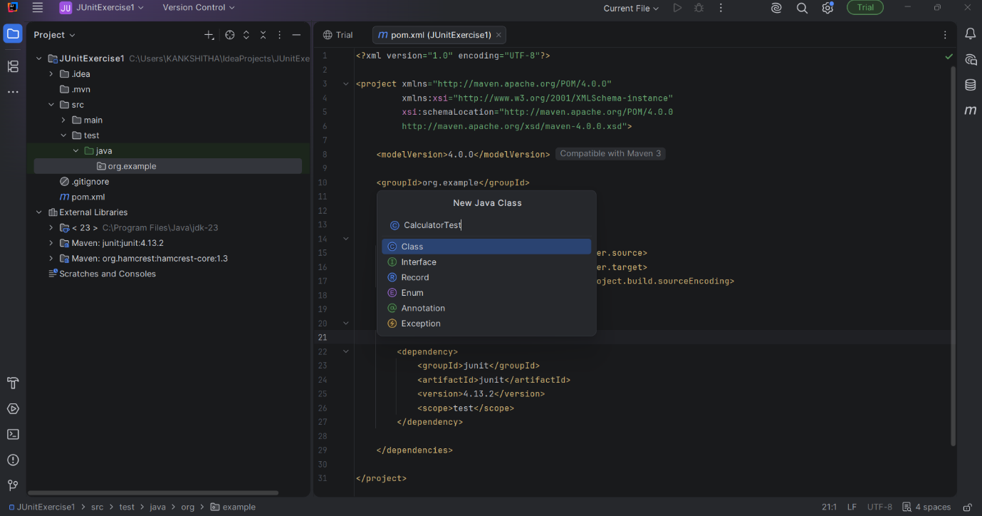
Press enter to create a java class.

Step8:- Write an example program in CalculatorTest and Run it
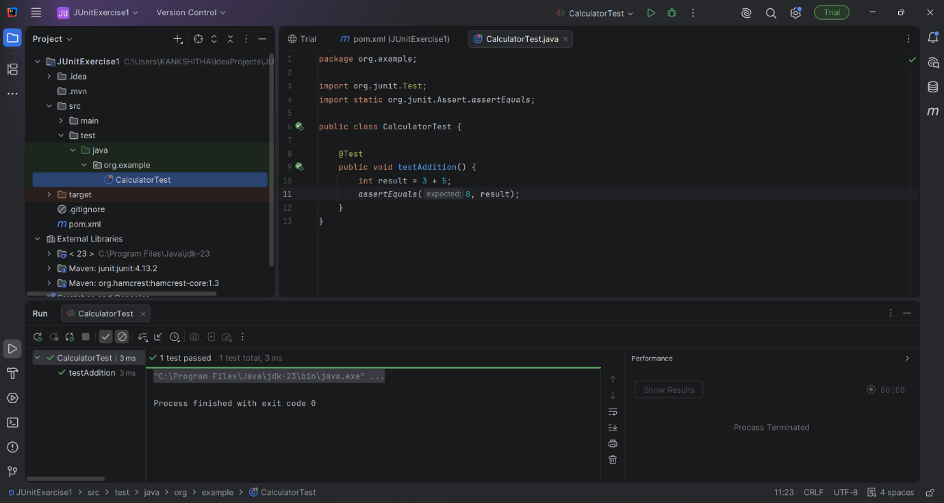
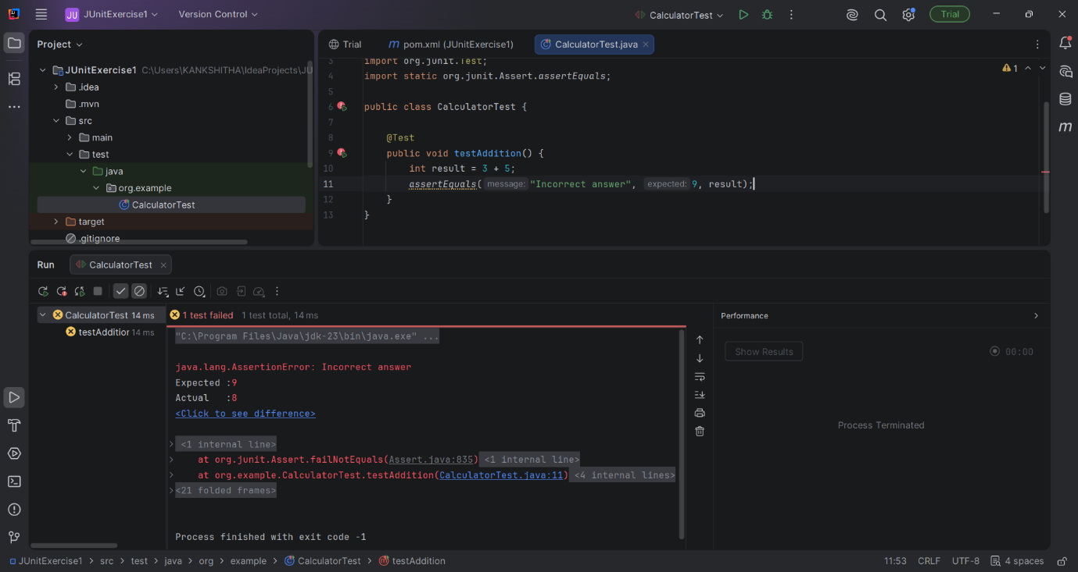
These are few various Outputs I got when I run a program.

